## horizontal line



Assignment # 1

CS322 - SC - Software Construction

**─**

Course Allocation System (Case Study # 1)

**Group no. 1**

**Team Members:**

1. Zakir Matloob ( Team Lead ) - 04072113055
2. Basid Ali - 04072113012
3. Ali bin Qadeer - 04072113033

**Submission Date:** 09-10-2023 09:00 AM

Signature Page

Quaid e Azam University

Department of Computer Science

**Course Allocation System Case Study**

The submitted document titled “Course Allocation System” is authentic work submitted by Zakir Matloob ( 04072112055 ), Basid Ali ( 04072113012 ), Ali bin Qadeer ( 04072113033 ) conducted at Quaid-i-Azam University, Islamabad. The document strictly follows the IEEE guidelines and ensures secure coding practices. All data from any source is referenced in the documentation. This document is not submitted to any platform but is a genuine combined effort of all our team members.

**Signature:**

Zakir Matloob 04072113055

Basid Ali 04072113012

Ali bin Qadeer 04072113033

Date: 09-10-2023

_________________

Sign of Instructor

**Preface**

This documentation outlines the development of the Course Allocation System, which automates and streamlines the process of course registration process within the Department of Computer Science. Observing the challenges faced by both faculty and students, we were asked to develop a more streamlined and user-friendly system. The system will begin with account verification to grant access only to the registered department student, and faculty members. Teachers will have the option to manage their profiles by offering courses, and students will have to view and successfully register courses of their respective semester on the basis of which pre-requisites they’ve passed which information will be received from the course evaluation system. All the data on this platform will be very well-maintained to enhance user accessibility and satisfaction.

**Change of History**

**Version 1.0** - Scope, Objectives, and deliverables submitted in Lab.

**Version 1.1** - Complete Project Plan Documentation.

**Table of contents**

1. Project Overview…………………………………………………………………………………...……………………………………………..05
   1. Project Summary……………………………………………….…...……………………………………………………………...05
   2. Purpose, Scope and Objectives ………………………………...……………….……………………………………………..05
   3. Assumptions and Constraints …………………………...………………………………………………….…………..……...07
   4. Project Deliverables…………………………...…………………………………………………………………..……….……...07
   5. Schedule Summary …………………………...…………………………………………………………………..…….………...08
2. References ………………………………………………………………………...……………………………………………….……………...08
3. Definitions ………………………………………………………………………………………………………………………………………..08
4. Project Context ………………………………………………………………………………………………...………………………………. 08
   1. Process Model ……………………………………………………………………………………………………………………….09
   2. Methods, tools, and techniques ……………………………………………………..……………………………………..…09
   3. Product acceptance plan ………………………………………………………………………………..………………………..09
5. Project Planning ………………………………………………………………………………………………………………..………………10
   1. Project Work Plans …………………………………………………………………………………………………………….….10
      1. Work Activities …………………………………………………………………………………………………………10
      2. Schedule allocation …………………………………………………………………………………………….…….11
      3. Resource allocation …………………………………………………………………………………………….…….11

8. Supporting Process Plans …………………………………………………………………………………………………………...……...11

8.1 Risk Management ………………………………………………………………………………………………..…………..11

**List of Figures:**

4.1 Agile Process Model ……………………………………………………………………………………………………………………... 09

5.1.2 Schedule ……….……………………………………………………………….………………………….…………………….............. 11

5.1.3 Resources ……………………………………………………………………………………………………………..………………….. 11

**List of Tables:**

8.1 Risk Management …………………………………………………………………………………………………..…………………….11

# Project Overview

## Project Summary

The course allocation system streamlines course registration in the Department of Computer Science. It features role-based access for the users in accordance with their credentials, pre-requisites check whose pass/fail information will be extracted from the Course Evaluation system, Maximum credit hour limit which will depend on the Program registered by the student, fee payment verification status and deadline enforcement for registration of courses. It may further expand to the other departments of Quaid e Azam University, offering a transparent and efficient course allocation process.

## Purpose, Scope, and Objectives

### **Purpose**

1. To automate and optimize the course registration process within the computer science department later covering all other departments of the university.
2. To provide a user-friendly system for students to register for courses, teachers to offer courses, and departments to obtain data.
3. Enhance transparency and streamline the course allocation process.
4. Reduce man-work.

### **Scope**

1. **Stakeholder**
2. Students
3. Teachers
4. Staff
5. **Functions**
6. Login Facility to students, teachers, and staff.
7. Students and Teachers can log into their accounts using credentials given by the department.
8. Course registration by students.
9. Notify students about course registration deadlines.
10. Teacher to offer courses.
11. Record maintenance of registered courses.
12. **Major Inputs**
13. Students and Teachers ID and password.
14. Courses to register by student.
15. Courses to be offered by the teacher.
16. Input from Course Evaluation System about Pass/Fail results for pre-requisites clearance check.
17. Fee submission Status.
18. **Major Outputs**
19. Courses information ( courses which he/she is allowed to register as per cleared pre-requisites and program ).
20. Course offered details.
21. Students' course registration details.
22. Deadlines for course registration.
23. Confirmation of successful or failed course registration.

### **Objectives**

1. **Data-Hiding:** The data of every user will be hidden from the other user, only he/she will be able to access that data.
2. **Accessibility and convenience:** Students will be able to access their data for course registration anytime without wasting any time while outside the department office, on their computer in the lab, or on their personal laptops.
3. **Scalability:**  Design the system to accommodate potential expansion to other university departments, allowing for a standardized and efficient course allocation process across the institution.
4. **Transparency and streamlining system:** Promote transparency by providing students with clear information about course availability, prerequisites, and registration status.
5. **Role-based access control: I**mplement role-based access control to ensure that students, teachers, and administrators can access only the functionalities relevant to their roles.
6. **Minimize the amount of paperwork:** Simplify and automate the course registration process to reduce manual administrative work and paperwork.
7. **User-Friendly Interface:** Create a user-friendly interface that enhances the user experience for students, teachers, and administrators.

## Assumptions and Constraints

1. **Software Constraints**
2. Integrated Project / Not stand-alone project.
3. Java For programming.
4. MS Word for Documentation.
5. Gantt chart on Project Libre.
6. Project Plan.
7. Desktop Application.
8. **Project Constraints**
9. Cost for the project.
10. Duration of 105 Days.

## Project Deliverables

* **Within Team:** 
  + Project Plan
  + Source Code
  + Gantt Chart
  + Analysis Model
  + Test Reports
  + Resources availability.
  + System Design.
* **To the End-User**
  + Final Product (Desktop Application).
  + Documentation.
  + Data backup and Recovery procedure.
  + Software Requirement Specifications.

## Schedule Summary

* 6 days for **Planning.**
* 21 days for **Analysis**
* 2 days for defining **Project deliverables.**
* 5 days for defining **use cases.**
* 4.5 days for **designing the Analysis model**
* 21 days for **design.**
* 28 days for **development.**
* 17 days for **testing.**

# References

1. Management (International Standard ISO/ IEC/ IEEE 16326 2nd Edition- 2019
2. Code-complete-2nd-edition by Steve McConnell.

# Definitions

| **Terms** | **Descriptions** |
| --- | --- |
| SRS | Software Requirement Specifications: |
| RBAC | Role-based Allocation system |
| UAT | User Acceptance Testing |
| PMP | Project Management Plan |
| QAU | Quaid-e-Azam University |
| Java | Computer-based Programming Language |

# Project Context

## Process Model

We will use the **agile process model** for the course allocation system for the following reasons:

1. Small team.
2. A portion of the product can be delivered to the customer after every milestone.
3. Continuous improvement in the project.
4. Changes and corrections can made.
5. Can take feedback from customers.
6. Iterative development which means reviews of tasks are done and can made adjustments.

## Methods, Tools, and Techniques

* **Methods**

1. Agile Process model.
2. Soft copies for deliverables.

* **Tools**

1. MS Word ( Documentation, Planning )
2. Project Libre ( Planning )
3. Visual Studio ( Development )
4. Computer Systems ( Validation )

* **Techniques**

1. Object-Oriented Approach.

## Product Acceptance Plan

As we are using an agile process model, we conduct a meeting after every task and provide milestones/deliverables of the task to the user. We will organize formal technical reviews (FTR) after every task. Based on the review, the required changes will be made. Alongside testing will be done of the following task. Also, check if the given task is completed within the duration (allocated time or not). Highly advanced computer software will be used for code testing. By the end, the overall review of deliverables will be conducted which requires a highly qualified reviewer alongside a third person who will record the review in an unbiased manner to verify the requirements are met or the product needs changes. This acceptance plan will be done for the better and higher quality of the final product.

# Project Planning

## Project work plans

### **Schedule allocation**

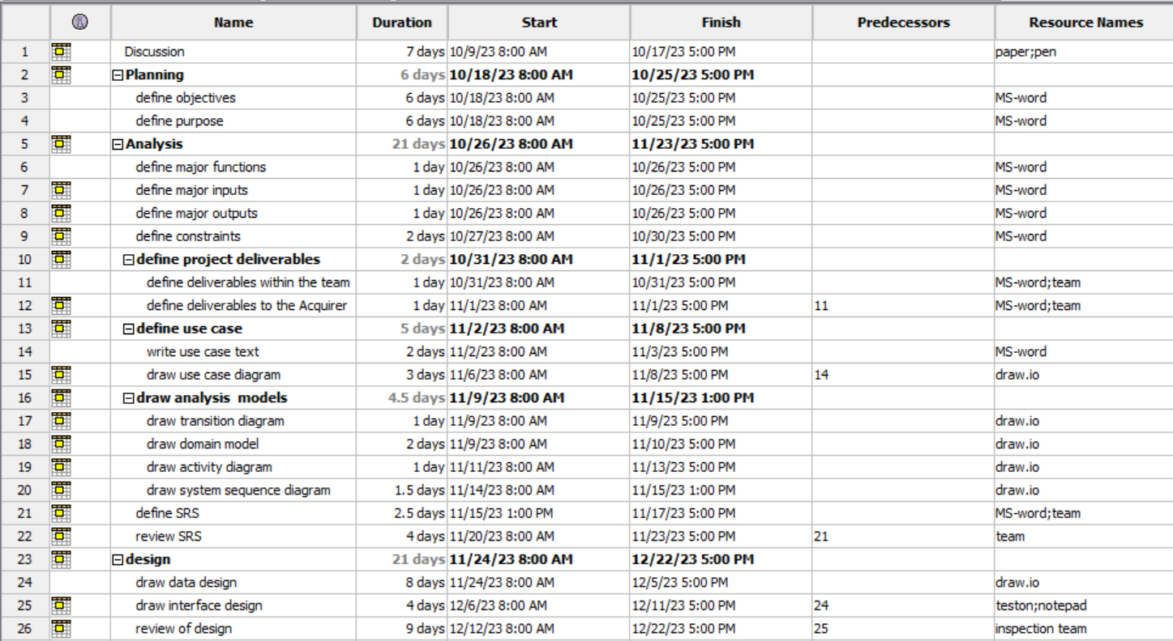

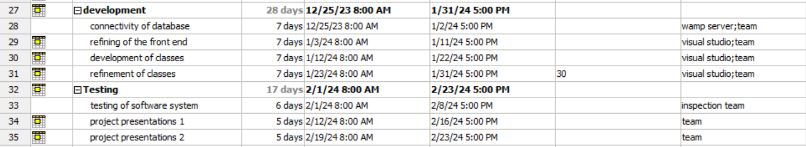

### **Resource allocation**

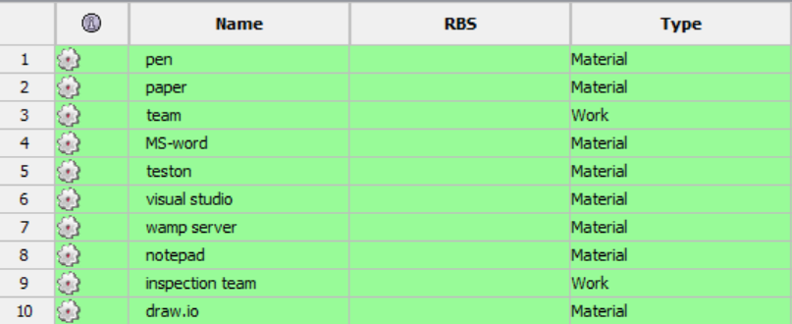

# 8. Supporting Process Plans

## 8.1 Risk Management

**Project Risks:**

| **Risk** | **Probability** | **Impact** | **RMMM** |
| --- | --- | --- | --- |
| Late submission of task | 30% | Task and project completion can delay | The manager/team leader must have to monitor the task and members regularly. |
| Unavailability of team member | 20% | Task and project completion can delay | If a team member needs to leave then we can schedule the task and extend the submission time, also we can hire a new member. |
|  |  |  |  |

**Technical Risks:**

| **Risk** | **Probability** | **Impact** | **RMMM** |
| --- | --- | --- | --- |
| Sluggish Response time | 40% | Users/customer feedback is not favorable, and they can get bored | High-quality testing should be conducted after every task. A thorough review of each task is essential. Additionally, obtaining feedback from the customer after each task is crucial. |
| The deliverable product did not meet the customer’s requirements | 20% | of Users/customer feedback is not favorable, and they can get bored. |  |
| Sluggish Response time | 40% | Users/customer feedback is not favorable, and they can get bored | High-quality testing should be conducted after every task. A thorough review of each task is essential. Additionally, obtaining feedback from the customer after each task is crucial. |
| The deliverable product did not meet the customer’s requirements | 20% | of Users/customer feedback is not favorable, and they can get bored. |  |

**Business Risks:**

| **Risk** | **Probability** | **Impact** | **RMMM** |
| --- | --- | --- | --- |
| Marking risk | 30% | 1. The product might not achieve the desired market position, leaving customers dissatisfied because it may not attract the intended user demographic. 2. The product's success in the market might be hindered, and customers could find themselves unsatisfied due to its inability to reach the desired user base. 3. Failing to secure its intended market position, the product may leave customers discontented as it falls short of attracting the targeted user group. 4. The product's inability to attain its expected market position may result in customer dissatisfaction, as it may not effectively reach its intended user base. | The product must have a well-structured schedule and launch ahead of competing products. The team leader must actively oversee the project to ensure timely delivery |